# Assignment (12.1) 14- Jan 2018

1. Use the given link Data Set.

Answer the below questions:

a. Perform ANOVA test on the discriminant analysis scores of nuclear localization signals of both nuclear and non-nuclear proteins by class variables (Target).

Sol :- For ANOVA test lets define NULL and Alternative hypothesis.

$H_{o}$: The mean of nuclear localization signals of the different groups are the same. $H_{a}$: At least one sample mean is not equal to the others.

res.aov<- aov(nuc~class, data = yeast_data)

summary(res.aov)

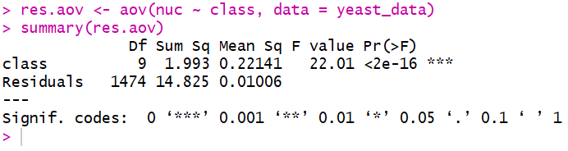

As the P value is less than the significance level of 0.05, we can conclude that there are significant differences between the groups highlighted with ‘*’ in the model summary.

b. Which class is significantly different from others?

Sol :- in one way ANOVA test , a significant p-value indicates that some of the group mean are different, but we don’t know which pair of group are different. It is possible to perform multiple pair wise comparison, to determine if the mean difference between specific pair of group is statistically significant.

As the ANOVA test is significant, we can compute TUKEY HSD (TUKEY HONEST Significant differences, R function: TukeyHSD()) for performing multiple pair wise comparison between the mean of the groups.

The function TukeyHSD() takes the fitted ANOVA as an argument.

TukeyHSD(res.aov)

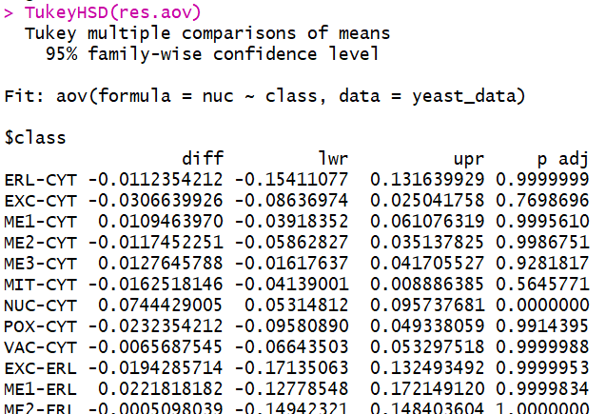

[ Very large output so CROPPED]

From above output we got following groups for which there is a significant difference between the means.

NUC-CYT 0.0744429005 0.05314812 0.095737681 0.0000000

NUC-EXC 0.1051068931 0.04924622 0.160967571 0.0000001

NUC-ME1 0.0634965035 0.01319448 0.113798528 0.0026743

NUC-ME2 0.0861881256 0.03912110 0.133255152 0.0000004

NUC-ME3 0.0616783217 0.03244028 0.090916364 0.0000000

NUC-MIT 0.0906947151 0.06521504 0.116174388 0.0000000

POX-NUC -0.0976783217 -0.17037079 -0.024985855 0.0009144

VAC-NUC -0.0810116550 -0.14102211 -0.021001196 0.0008397